Database Schema

- Use docker exec command to run “rag-postgres” to enter the postgres
- Enable pgvector extension using the create extension if not exists command
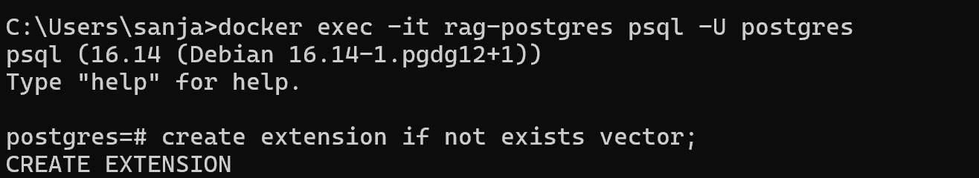
- Create table with the following schema:
  - id: auto incrementing primary key variable
  - d_name: string that stores document name(null value not permitted)
  - chunk_text: result from chunking is stored here as text
  - created_at: useful for version control
  - embedding: array that accepts 384 numbers; sentence transformer model(sentence-transformers/paraphrase-multilingual-MiniLM-L12-v2)
returns an array of 384 numerical values
